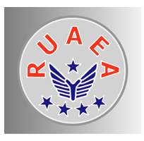
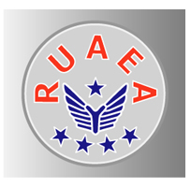
Retired United Airlines Employees Association
Membership Application
Effective 1/1/2019
RUAEA is an organization of previous employees of United Airlines, Continental Airlines, their subsidiaries and others who have reached the age of retirement. RUAEA’s purpose is to help retirees continue into retirement and to maintain the bonds of friendship and fellowship developed during their careers. It also is to be a proactive voice for the retiree’s interest, issues and causes. RUAEA has established and will continue to maintain a cordial relationship with United Airlines and will assist United Airlines in communicating information concerning policies, plans, benefits, services and etc. to the members.

The primary activities of RUAEA are the publication of a national Newsletter, (via print and website) support local chapters and conduct an annual convention.

USE THIS FORM TO APPLY FOR NEW MEMBERSHIP, (DOMESTIC, OR FOREIGN), OR TO REINSTATE YOURSELF IF YOU HAVE BEEN IN THE ARREARS FOR MORE THAN ONE (1) YEAR.

Below are the rates effective 1-1-19. Following initial application and payment your dues will be renewable in “The month you joined. This is considered your renewal date.” Please check the appropriate box below. INCLUDE YOUR UAL/CO FILE OR EMPLOYEE NUMBER ON YOUR CHECK.

□ Annual Dues for New Members and for Returning Members (In Arrears) $30.00 U.S. Currency

□ Annual Dues for Residents of Canada/Mexico $47.00 U.S. Currency

□ Annual Dues for Residents in any other foreign country $52.00 Drawn on a
U.S. Bank, or paid with an American Express Check.

DUES OPTIONS:

□ Canada/Mexico and Foreign members may receive the Newsletter by WEB only at the Domestic rate.

□ Web and Paper $5.00 additional per year. NOTE: This option is not available for Life Members

NOTE: To have access to the online newsletter you must go to www.ruaea.org to obtain a “Password”

PLEASE PROVIDE THE FOLLOWING INFORMATION:

Retired from, check one UAL ______, CO _______, OTHER (Please name), ________________________

UA/CO File/Emp Number ____________ First Name ___________________ Last Name _________________________________

Street Address ______________________________________________________ Name of Spouse __________________________

City _______________________________________________ State ___________________________ Zip Code ________________

Last Company Address Code _________ Department ________ Home Phone Nbr (_________) ___________________________

Email Address: ______________________________________________________

Make your check payable to RUAEA; mail to: RUAEA or pay online at www.ruaea.org
7401 E. MLK BLVD. 
DENVER, CO. 80207-2433
303-780-5022
“WE HOPE YOU WILL SHARE RUAEA’S PROUD HERITAGE BY BECOMING A MEMBER”

Rev 1/1/2019

